Restore the Pearland Depot
Donate a Brick or Bench

Help us restore the Pearland Depot by donating to personalize your very own brick or bench. The donations will be
used to restore and preserve the Gulf, Colorado and Santa Fe Railroad Depot on Liberty Drive in Pearland.
Your BRICK will be installed to create a lasting walkway in the heart of the Depot site for visitors to use and enjoy for years to come. Your BENCH will be installed around the Depot grounds for museum goers to sit upon while visiting Pearland’s restored Depot. All bricks and benches will be made of concrete material.

To donate, simply select the brick or bench option below, fill out the reservation form below and email to: amandahayes@swbell.net. For any further information, please call Amanda Hayes -281-773-9467.

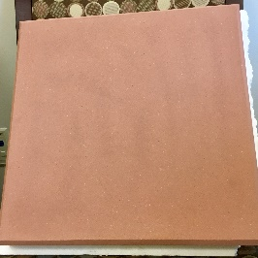
Donate a BRICK --- (16 characters per line, all capped in Helvetica)
_____ 4” x 12” - 2 lines of copy - $150.00 4” x 12”
_____ 8” x 12” - 4 lines of copy - $300.00
_____ 12” x 12” - 6 lines of copy - $400.00 16” x 16”
_____ 16” x 16” – 14” x 14” engraved area copy or logo - $500.00 square

Donate a BENCH --- (customized message; special engraving form provided)
_____ 14” x 48” x 3” - sits on 2/22” tall bases - $1500.00

--------------------------------------------------------------------------------------------------------------------------

RESERVATION FORM:
Contact Name ________________________________________________________________________________
Address _____________________________________________________________________________________
City _______________________________________________ State________________ Zip ________________
Email Address ________________________________________________________________________________
Phone ______________________________________________________________________________________
PAYMENT INFORMATION:
TOTAL PAYMENT: $___________________________
Make check payable to “Pearland Historical Society”
(Payments for the memorial bricks and benches are received by the Pearland Historical Society, a 501(c)3 non-profit organization.
Your donation is tax deductible to the extent allowed by law. Tax ID 76-0256510)

Mail check with completed form to:
Amanda Hayes, 4606 Russett Place South, Pearland, TX 77584

Completed order includes: Reservation form and engraving form filled out and payment.

This project is a collaborative effort among the Pearland Citizens Depot Committee, Pearland Historical Society and Pearland Convention & Visitors Bureau.

Brick Engraving Form

Print your brick inscription in the boxes below, up to 16 characters per line, including letters, spaces and punctuation.

Return your completed engraving form by email to: amandahayes@swbell.net
For any further information, please call Amanda Hayes -281-773-9467

4” x 12” brick ($150) – 2 lines of copy, 16 characters per line, Helvetica, all caps

8” x 12” brick ($300) – 4 lines of copy, 16 characters per line, Helvetica, all caps

12” x 12” brick ($400) – 6 lines of copy, 16 characters per line, Helvetica, all caps

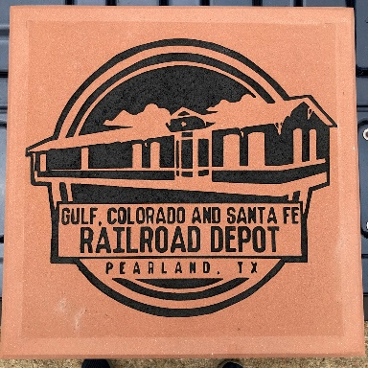
16” x 16” brick ($500) – 14” x 14” engraved area with customized copy OR logo

PLEASE CALL FOR
SPECIAL ENGRAVING ORDER INSTRUCTIONS!

This project is a collaborative effort among the Pearland Citizens Depot Committee, Pearland Historical Society and Pearland Convention & Visitors Bureau.

